Lecture 23

CPSC 131

11/18/2020

1. A Review of Associated Containers (aka maps and sets)
   1. As you know, maps have 2 keys (a key and a value) while sets have one (values)
2. Hash table
   * 1. Concept: put a value into a bucket
     2. It uses the bucket iterator
     3. Basically you throw a value into a bucket and the bucket is supposed to be a lot less restrictive than the other containers
     4. A visual   
        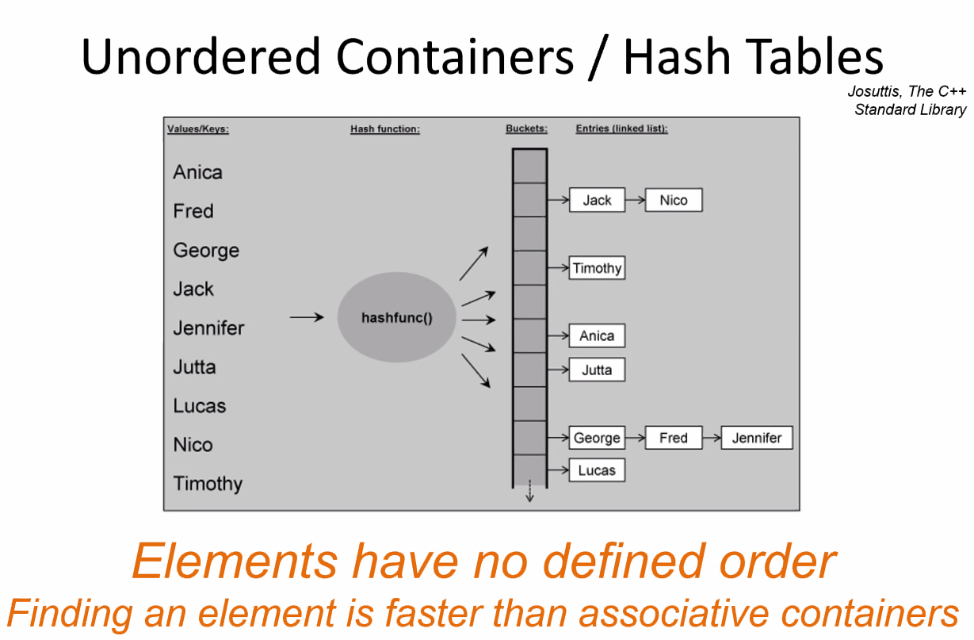
     5. Hashfunc() is constant time O(1)
     6. It’s not dependent on the number of elements in the function
   1. Unordered containers  
      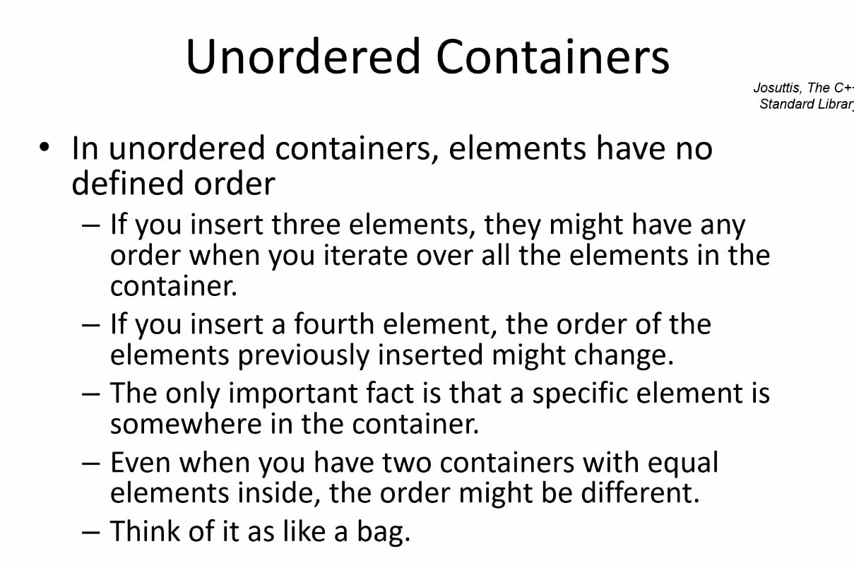
      1. No order but CHAOS
      2. It is an array of linked lists  
         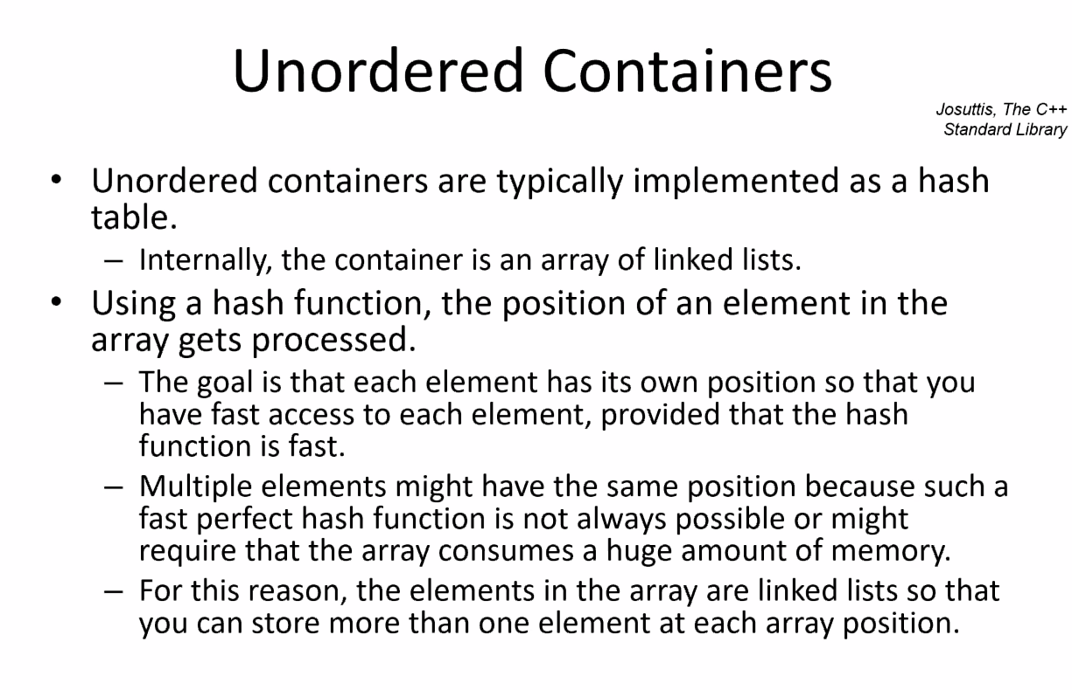
      3. Hash: gets key, gives index
      4. Major Advantage  
         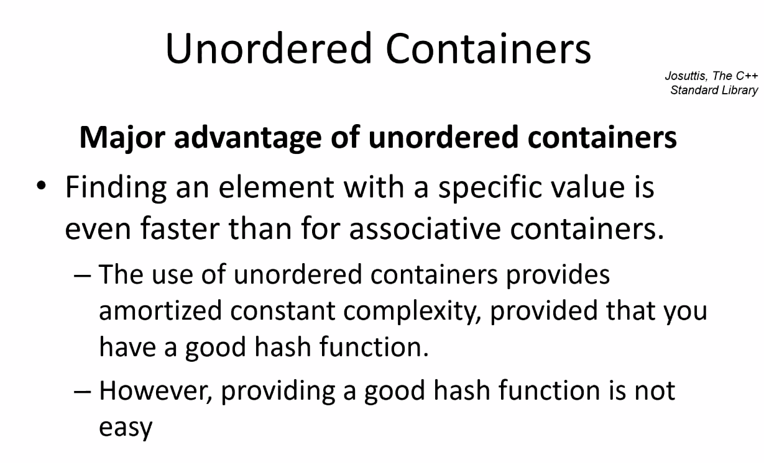
      5. O(1) ?  
         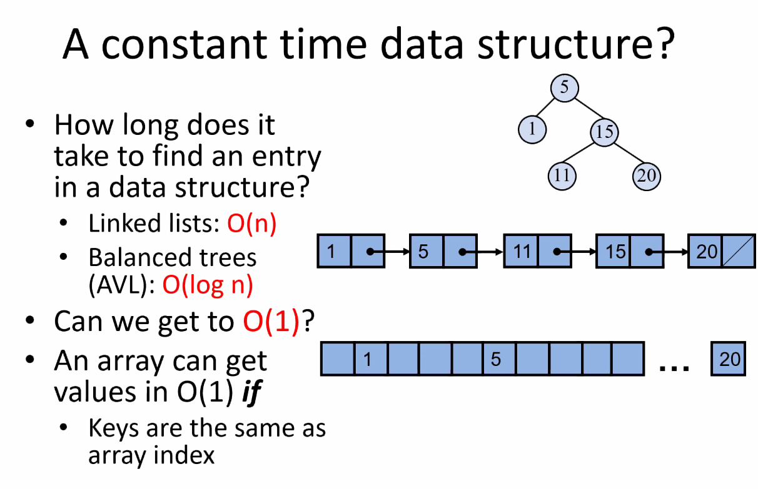
      6. Disadvantages  
         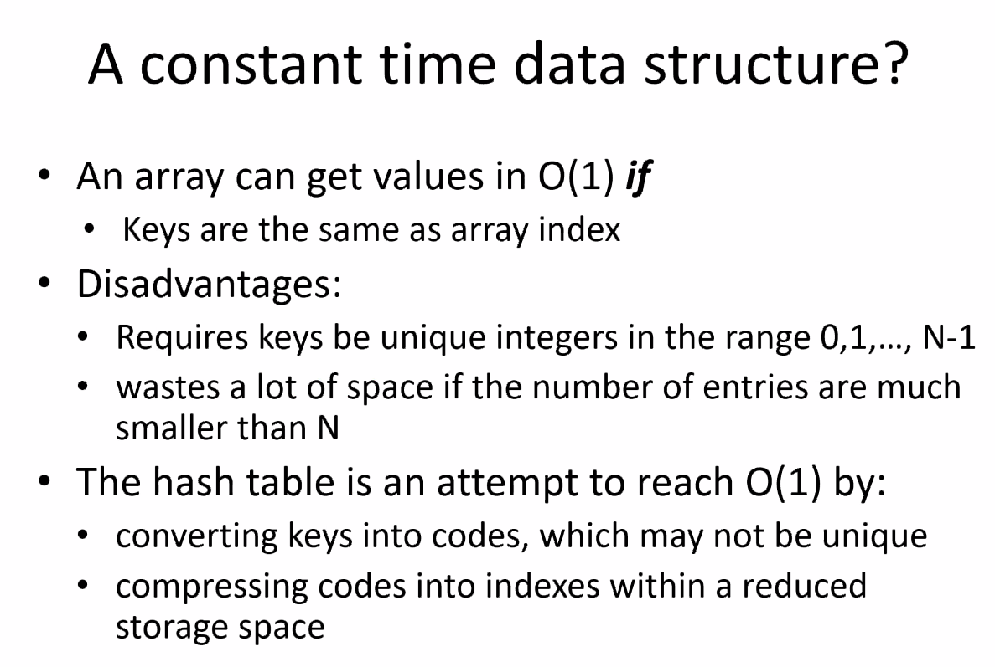
      7. Main Idea  
         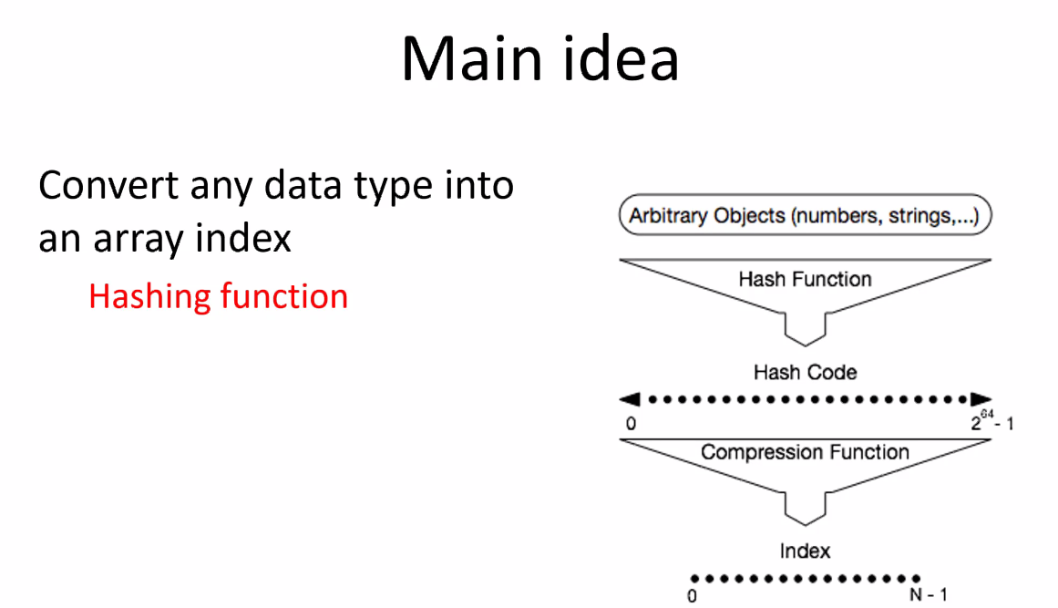
         1. The hashing functions has two parts to it
            1. A good hashing will spread its value over a large number of bits where typically on 64-bit machines will be pretty good
            2. However, on bigger bits you need to compress it
      8. Hash Table summary  
         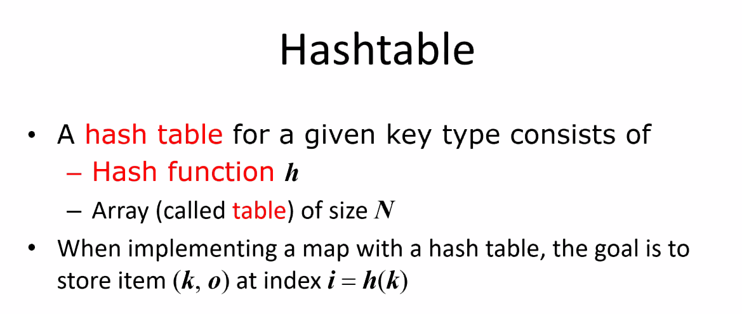
         1. (Key,value) pairs  
            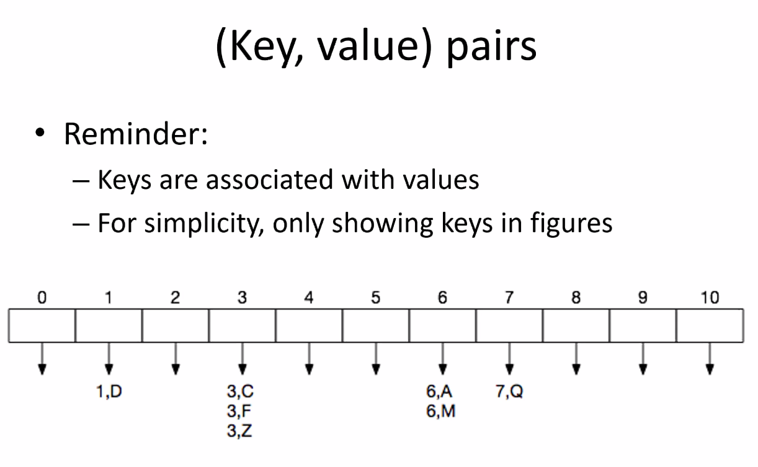
      9. Compression Function  
         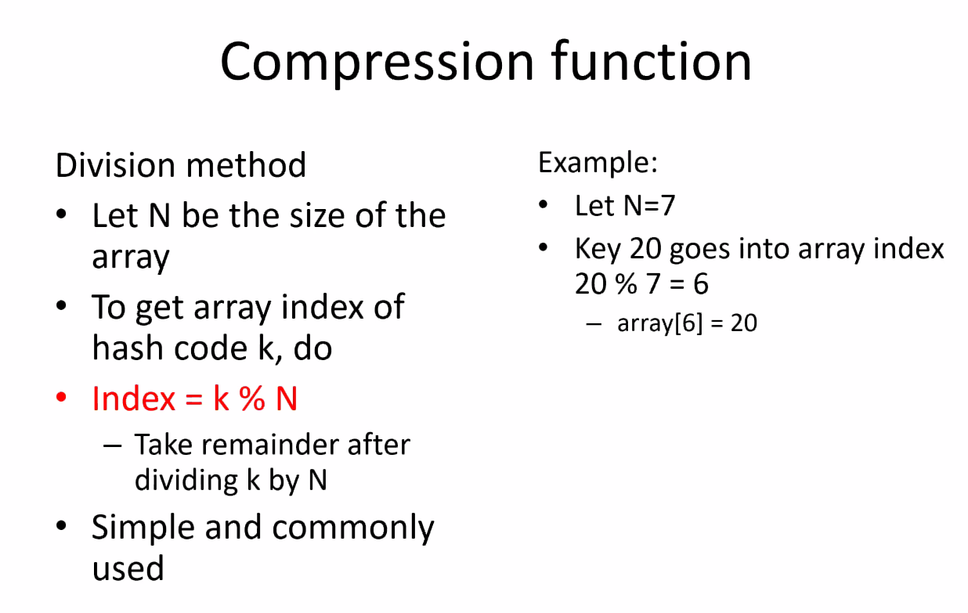
         1. If you have 10,000 keys, what’s the remainder of it devided by 7? That remainder would be your bucket number.
         2. The compressions is just a simple module that takes the key (large bit pattern) and see above
         3. Example  
            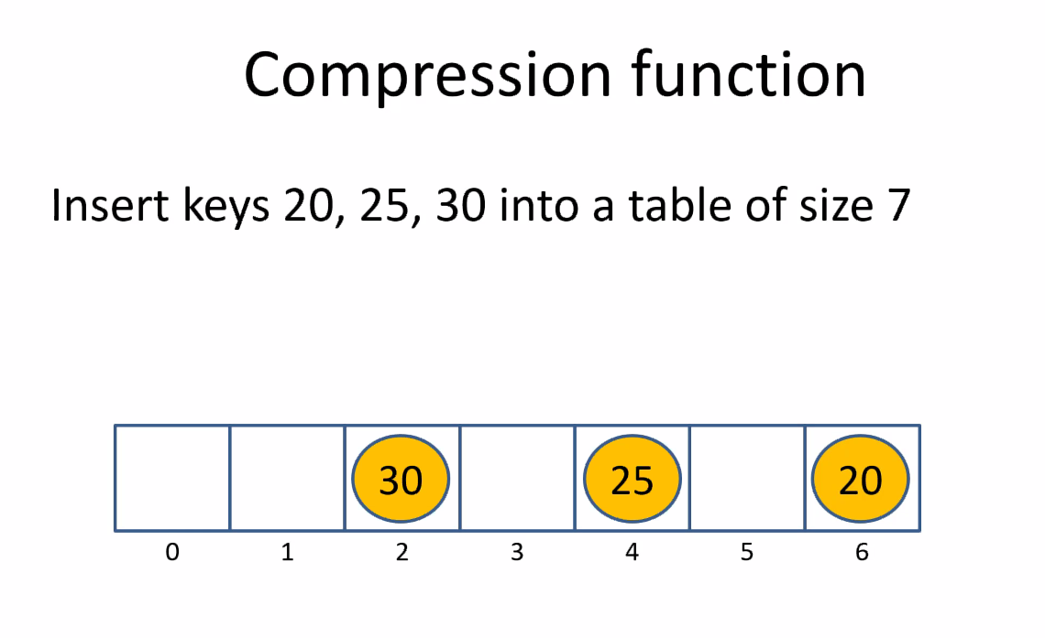  
            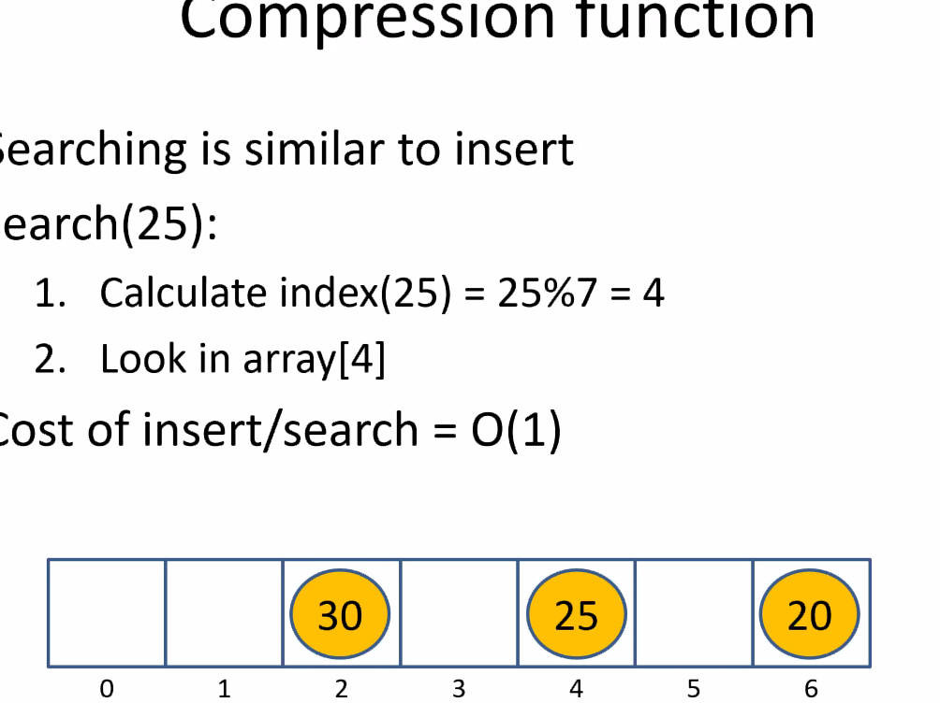  
            The cutoff part says Search(25):
   2. We’ll get into Collisions next time